7.1 Slope-intercept form
Extra Examples

- What is the slope-intercept equation of the line?
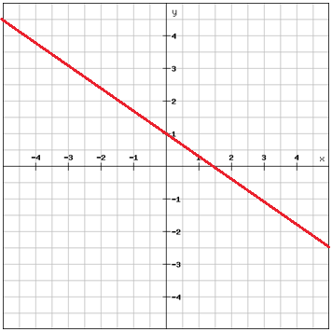

- What is the slope-intercept equation of the line?
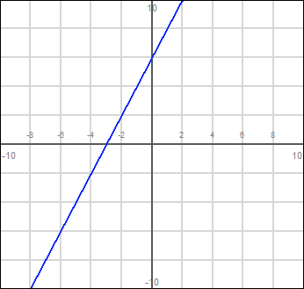
3. Graph the following equations by hand,
a) y = (1/4)x - 2

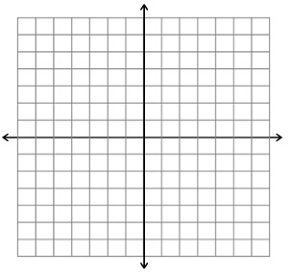

b) y = - 3x + 4

c) y = -(1/2)x

4. Rewrite the following equations into slope-intercept form.
a) 6 + y - 5x = 0

b) 2y + 7x - 12 = 0

c) -y + ¼ x = 0

5. a) Find an equation of the line that have the two points (0, 4) and ( -3, 2). Write it in slope-intercept form.

b) Find an equation of the line that have the two points (-4, 2) and (-3, 5). Write it in slope-intercept form.

