Chapter 7: Linear Equations and Graphs

Review (6.5 Slope)

- How can you find the slope?

- What is the slope of the following graph?
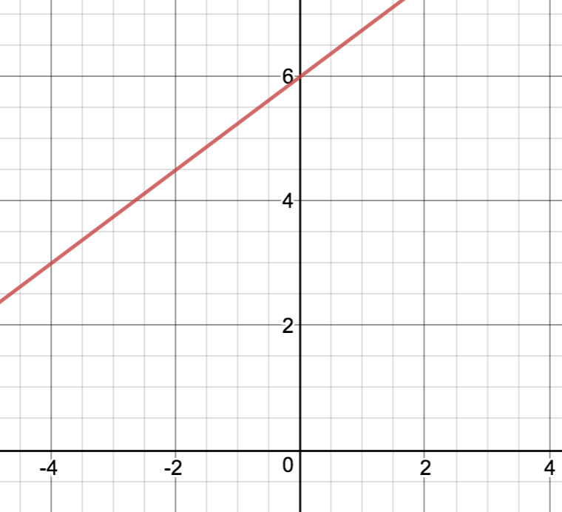

- Determine the slope of the following:
  - $y = 5x - 3$

Slope = ___________

  - $2y = -6x + 3$

Slope = ___________

  - $y = 0.5x - 2.5$

Slope = ___________

7.1 Slope-Intercept Form

Outcome: 3. Demonstrate an understanding of slope with relations to rise and run, and line segments and lines
6. Relate linear relations expressed in slope-intercept form to their graphs.
7. Determine the equation of a linear relation using a graph and a point and the slope to solve problems.

Definitions:
Y-Intercept: the y-coordinate of the point where a line or curve crosses the y-axis
You can find the value of y when x=0

Example: y = 2x - 12 when x = 0, y = -12 ; (0, -12)

Slope-Intercept Form: the equation of a line in the form y = mx + b
- m = the slope
- b is the y-intercept
Parameter: a variable that has a constant value in a particular equation

Example: y = 10m + 100. Determine the value of the parameter b.

Solution: “the parameter, b, represents the y-intercept, which is equal to 100”

Example 1:
What are the slope and y-intercepts of each equation?
- y = 25x + 3

- y = 5x

- y = 7

- y = ½ x - 4 ½

- y = ⅗ x + 2

- y = 2x - 1

Example 2:
- What are the slope and y-intercept of the line shown in the graph?
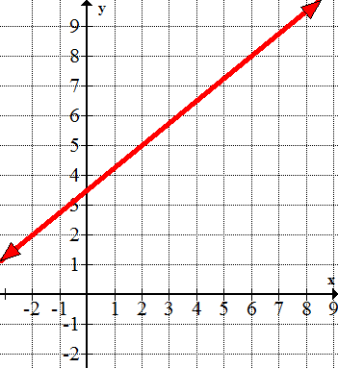

- What is the equation of the line in slope-intercept form, y = mx + b?

- Use graph technology to check your equation.

Example 3:
Parents of members of the cheerleading squad rent a hall. They arrange a talent show as a fundraiser. The relationship between the number of tickets sold, x, and the profit, y, in dollars, may be represented by the equation 12x - y - 840 = 0.
- What is the slope of the line? What does the slope represent?

- Identify the y-intercept. What does it represent?

- How many tickets must the parents sell to reach the break-even point?

Example 4:
Asha has selected a hotel for her wedding reception. The cost involves a fee for the deluxe ballroom and a buffet charge that depends on the number of guests. This is shown in the table.
Number of Guests | Cost ($)
0 | 425
25 | 1800
50 | 3175
75 | 4550

- Sketch a graph of the data in the table.

- What are the slope and y-intercept of the line? What does each parameter represent?

- Write an equation that describes the relationship between the cost and the number of guests. Express the equation in slope-intercept form.

- What is the cost for 140 guests?

- Asha would like the total cost to be no more than $15,000. What is the maximum number of guests that can attend?

Example 5:
A decorator’s fee can be modelled by the equation F = 75t + b. In the equation, F represents the fee, in dollars, t represents time, in hours, and b represents the cost of the initial consultation, in dollars.
- Suppose the decorator spends 4 hours working for a client and charges the client $450. Determine the value of the parameter b.

- How many hours does the decorator work if a client is charged $975?

Key Ideas
- The slope-intercept form of a linear equation is y = mx + b, where m is the slope of the line and b represents the y-intercept
Example: y = 2x + 1

The slope = 2 y-intercept = 1
$\frac{rise}{run} = \frac{2}{1}$ the graph passes through (0, 1)
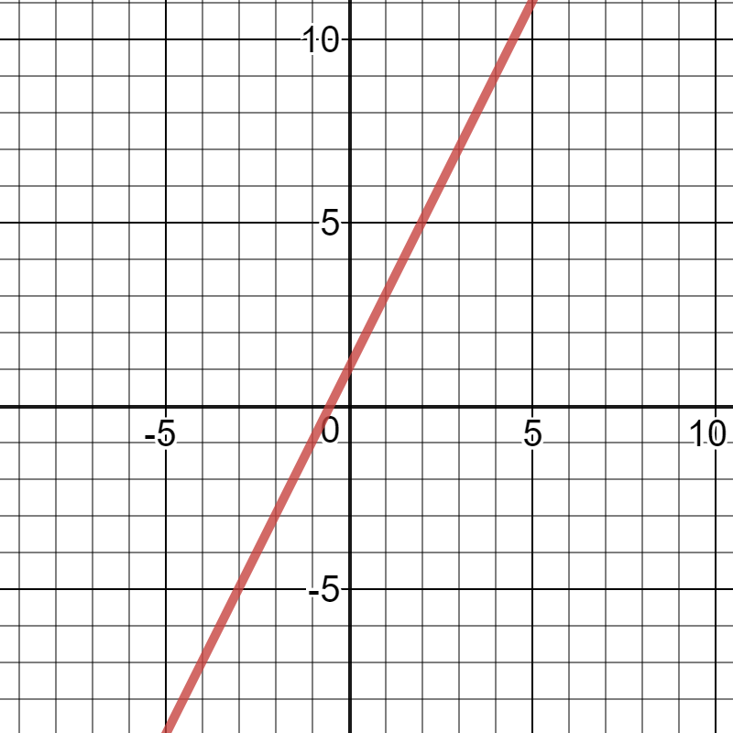

Textbook Questions: pg. 349 # 1 - 13, 15, 17
7.2 General Form

Outcome: 6. Relate linear relations expressed in general form to their graphs.

Definitions:
General Form: the equation of a line in the form Ax + By + C = 0
- Where A, B, and C are real numbers
- A and B are not both zero.
- By convention, A is a whole number. This means that A will always be positive
Example: 3x + 5y - 11 = 0

X-intercept: the x-coordinate of the point where a line or curve crosses the x-axis.
- The value of x when y = 0
Example: y = 2x - 12, when y = 0, x = 6 ; (6, 0)

Example 1:
Rewrite the equation in general form, Ax + By + C = 0
- y = $\frac{3}{4}x-2$

- y = $-x-5$

- y =$\frac{2}{5}x +\frac{1}{8}$

- y = $\frac{4}{3}x + 6$

Example 2:
Consider the linear equation 4x + 5y - 20 = 0
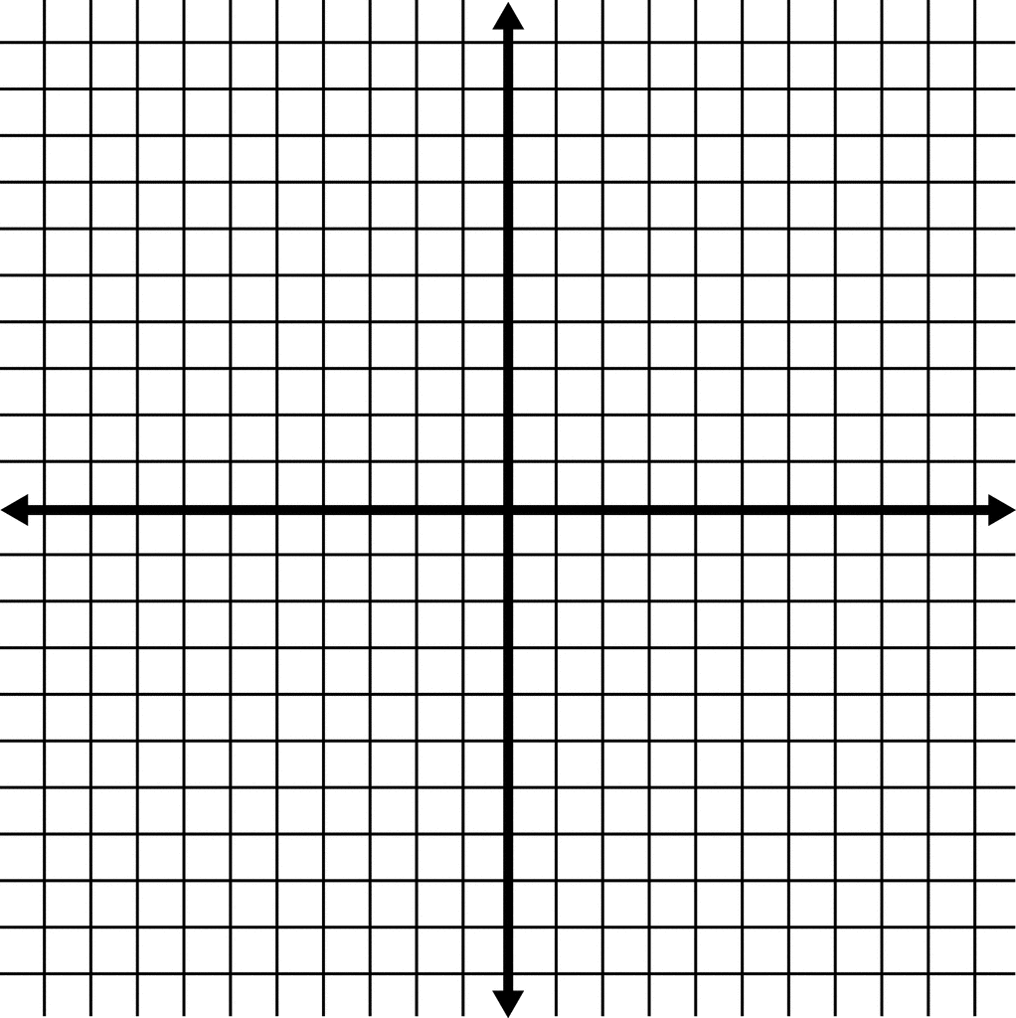
- What is the x-intercept of a graph of the equation?

- What is the y-intercept of the graph of the equation?

- Use the intercepts to graph the line.
Example 3:
Sketch each linear relation and identify the intercepts. What are the domain and range for each relation?
- x - 3 = 0
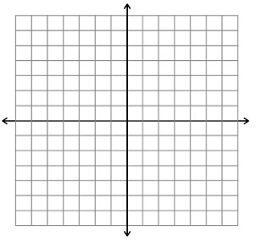

- x = 0
c) y + 2 = 0
Example 4:
Brooke wants to save $336 to decorate her bedroom. She has two part-time jobs. On weekends, she works as a snowboard instructor and earns $12 per hour. On weeknights, she earns $16 per hour working as a high school tutor.
- Write an equation to represent the number of hours Brooke needs to work as a snowboard instructor, S, and as a tutor, T.

- What is the S-intercept of a graph of the equation? What does the S-intercept represent?

- What would the T-intercept be? What does it represent?

- Suppose Brooke works 8 hrs as a snowboard instructor. How many hours will she need to work as a tutor?

Key Ideas
- The general form of a linear equation is Ax + By + C = 0, where A, B, and C are real numbers, and A and B are not both zero. By convention, A is a whole number.
- To graph an equation in general form, determine the intercepts, the draw a line joining the intercepts; or convert to slope-intercept form.
- To determine the x-intercepts, substitute y = 0 and solve.
To determine the y-intercepts, substitute x = 0 and solve.
- A sketch of a linear relation may have one, two or an infinite number of intercepts. A line that represents an axis has an infinite number of intercepts with that axis. A horizontal or vertical line that does not represent an axis has only one intercept.
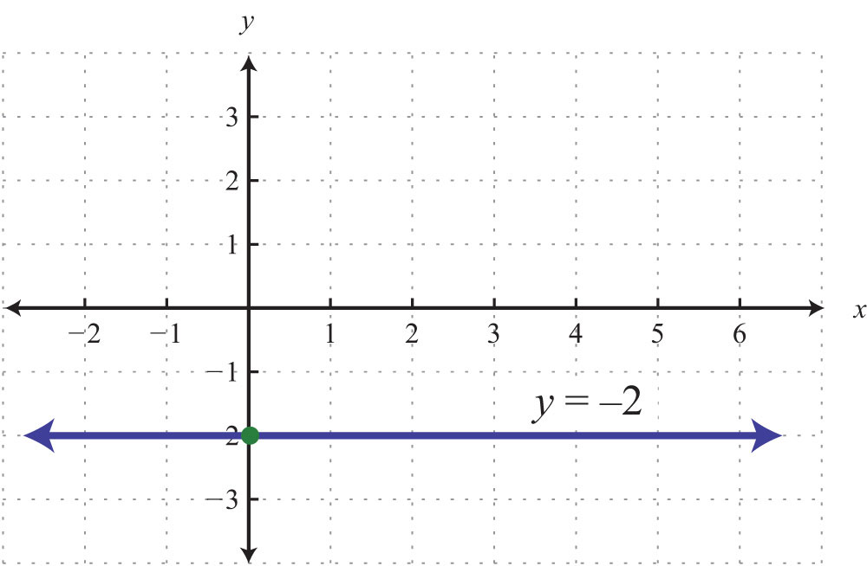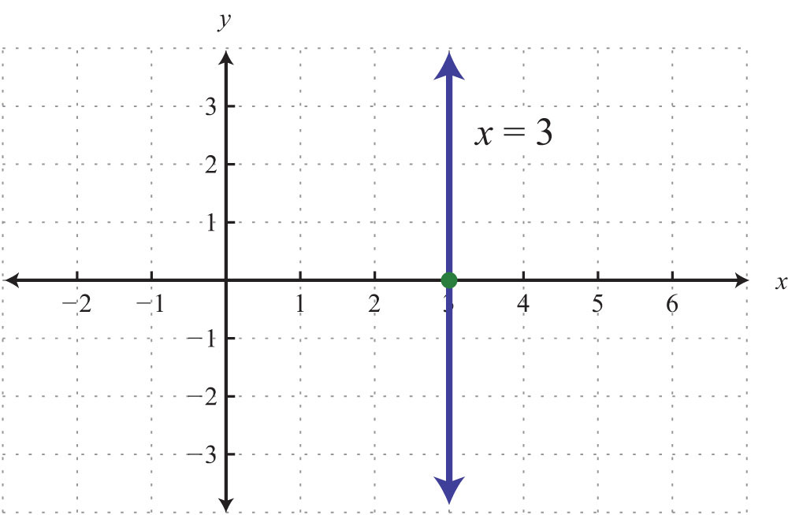

Textbook Questions: Pg. 365 # 1 - 8, 10, 13 -15

7.3 Slope-Point Form

Outcome: 6. Relate linear relations expressed in slope-point form to their graphs.
7. Determine the equation of a linear relation using a graph, a point and the slope, and two points to solve problems

Definitions:
Slope-Point Form: the equation of a non-vertical line in the form $y-y_{1}=m(x-x_{1})$
- Where m is the slope, and $(x_{1},y_{1})$ are the coordinates of a point on the line

Example 1:
Write an equation in slope-point form, $y-y_{1}=m(x-x_{1})$ , of the line passing through the given points.
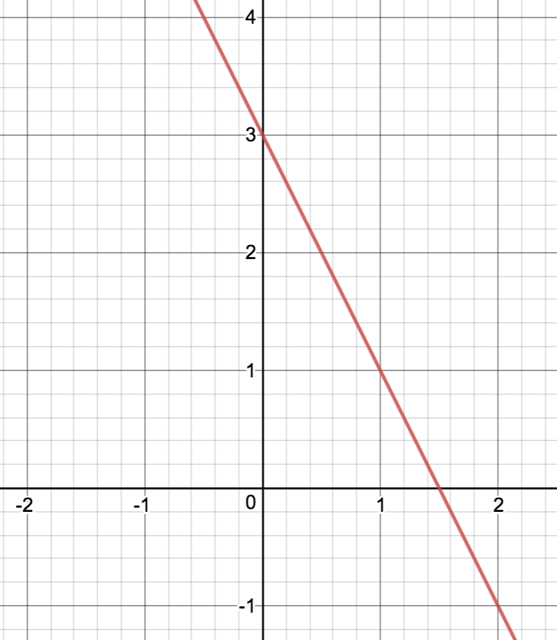

b) convert the equation to general form Ax + By + C = 0, and slope-intercept form y = mx+b

Example 2: Writing an Equation of a Line Using Two Points
Use slope-point form to write an equation of the line through (-5, 2) and (-2, 1). Then, write the equation in general form, Ax + By + C = 0

Example 3: Writing an Equation of a Line Using a Point and Slope
- Use slope-point form to write an equation of the line through (3, -4) with slope 2. Sketch a graph of the line.

- Express the equation in slope-intercept form, y = mx + b. Sketch a graph of this line.

- Compare your graphs.

Example 4:
A family drives at a constant speed from Calgary, AB, to visit relatives in Edmonton, AB. When they start driving at 9:00 am, they are 300km away from Edmonton. At 10:30am they reach Red Deer located 154 km from Edmonton.
- Write an equation that describes the distance, d, in kilometers, from Edmonton in terms of t hours past 9:00 am.

- What time will the family reach Edmonton?

Key Ideas
- The slope-point form of a non-vertical line in the form $y-y_{1}=m(x-x_{1})$, where m is the slope, and $(x_{1},y_{1})$ are the coordinates of a point on the line.
- An equation written in slope-point form can be converted to either slope-intercept form or general form
- Any point on a line can be used when determining the equation of a line in slope-point form.

Textbook Questions: Pg. 377 #1 - 3, 5 - 8, 10 - 14
7.4 Parallel and Perpendicular Lines

Outcome: 3. Demonstrate an understanding of slope with relations to parallel lines and perpendicular lines.
7. Determine the equation of a linear relation using a point and the equation of a parallel or perpendicular line to solve problems.

Definitions:
Parallel Lines: lines in the same plane that do not intersect
- Lines that have the same slope, but different intercepts
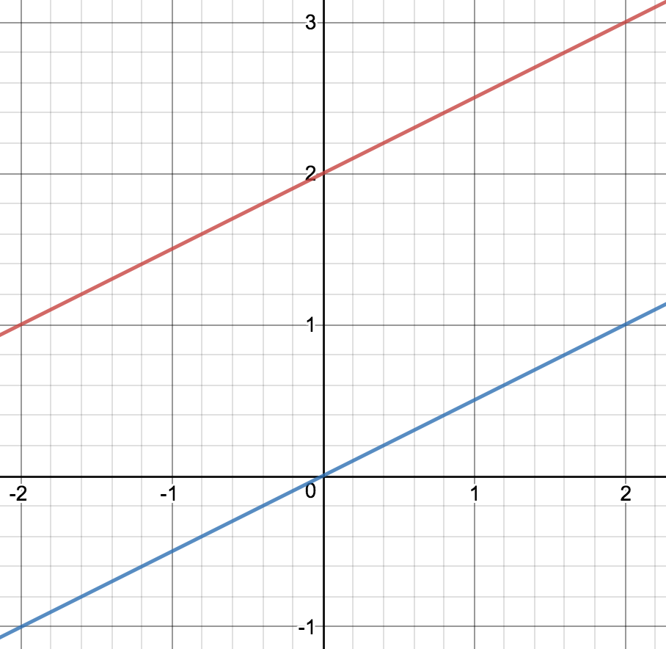

Perpendicular Lines: two lines that intersect each other at right angles (90 degrees)
- Lines that have slopes that are negative reciprocals of each other.
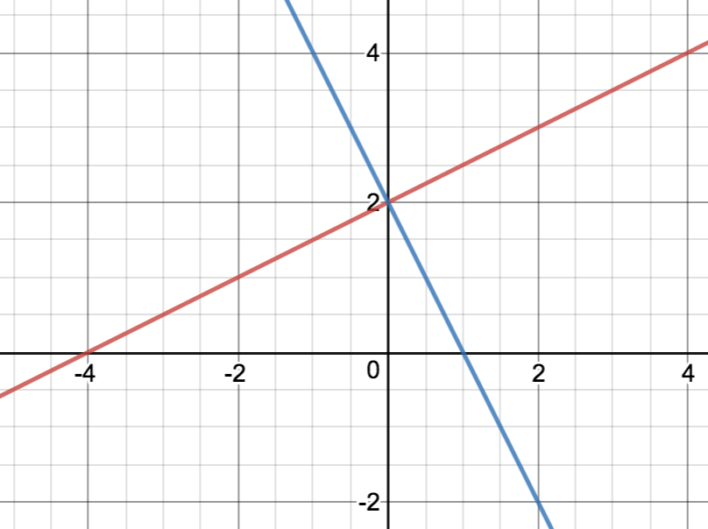

Example 1:
State the slopes of lines that are parallel and lines that are perpendicular to each linear equation.
- $y =3x+5$

- $2x-5y -10 = 0$

Example 2:
Determine whether the lines in each pair are parallel, or perpendicular, or neither.
- $y =\frac{1}{2}x-7$
$y = 2x-7$

- $y = 3x-4$
$y = 3x+\frac{1}{4}$

- $y = \frac{2}{5}x -6$
$5x+2y=8$

Example 3:
Write an equation in slope-intercept form of a line that is parallel to 3x + y + 3 = 0 and passes through (5, -6). Use technology to verify that the lines are parallel.

Example 4:
A line is perpendicular to 4x + y - 12 = 0 and passes through (8, -6). Write the equation of the line in both slope-intercept form and general form.

Key Ideas
- Parallel lines have the same slope and different intercepts. Vertical lines are parallel to each other, as are horizontal lines, if they have different intercepts.
- Perpendicular lines have slopes that are negative reciprocals of each other. A vertical line with an undefined slope and a horizontal line with a slope of zero are also perpendicular.
- The properties of parallel and perpendicular lines can give information about the slopes. Knowing the slopes can help you develop an equation.
  - A line perpendicular to $y=5x+7$ has the same y-intercept. The line $y=5x+7$ has a slope of 5 and a y-intercept of 7. The perpendicular line has a slope of -⅕ and a y-intercept of 7. So, the equation of the perpendicular line is $y= -\frac{1}{5}x+7$

Textbook Questions: Pg 390 # 1-8, 10-13, 15

